

**4MM013 - Computational Mathematics**

Mathematics Assignment-2

Full Marks: 20

University ID : 2329584

Submitted by : Akriti Kumari Dev

Submitted on :

1. Using Cramer’s rule obtain the solutions to the following set of equations:

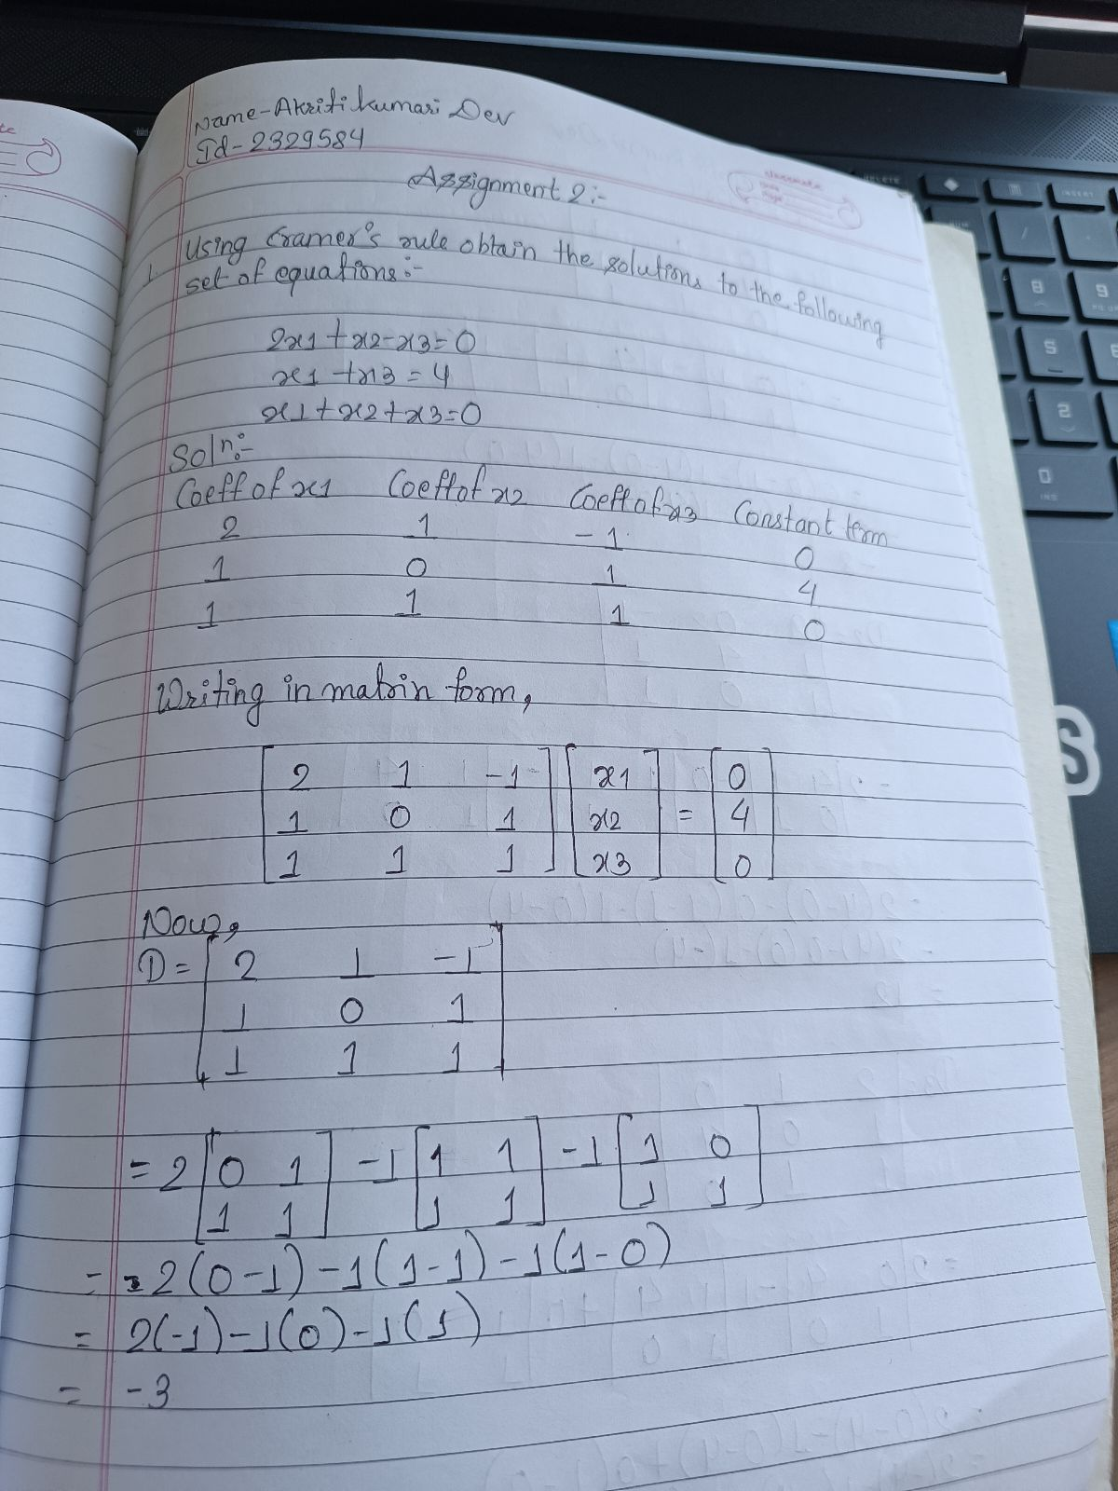

(4)

1. Solve the following using Gauss elimination:

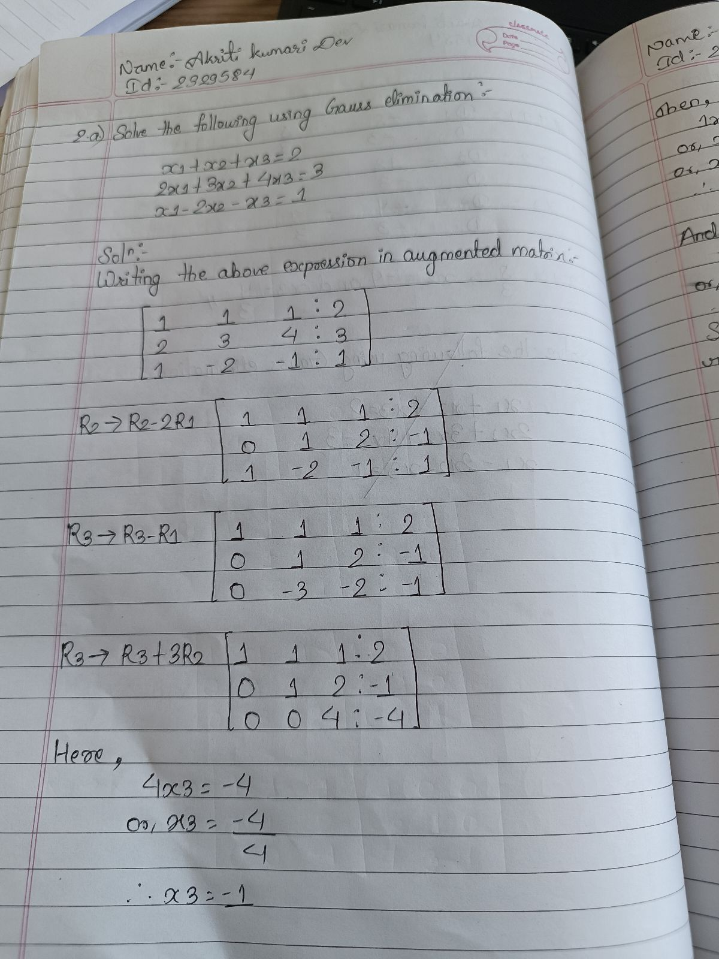

(4)

1. Find the inverse of the matrix from (a) using elimination.

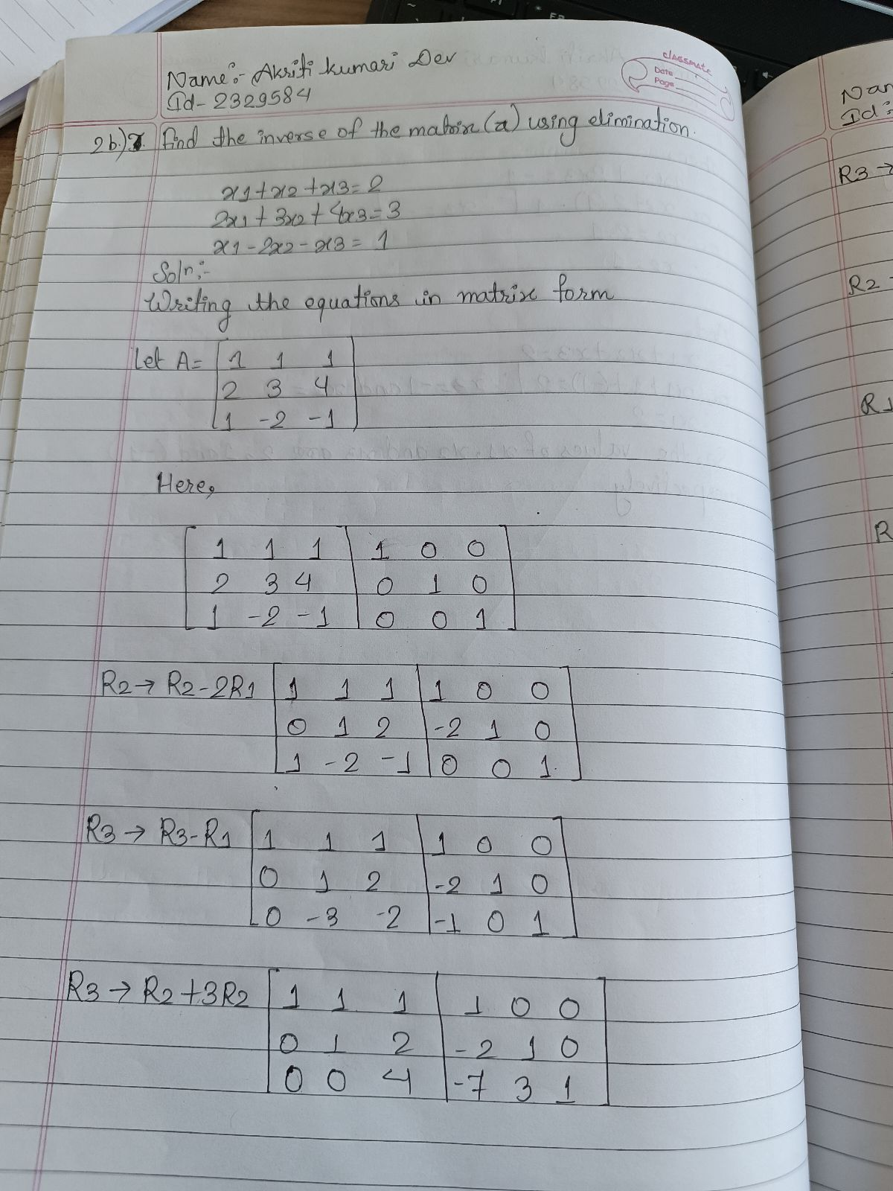

(4)

1. Determine whether the following sequence converges or diverges.

(4)

1. Find the Maclaurin series expansion of **Sinx,** also calculate the radius of convergence. (4).

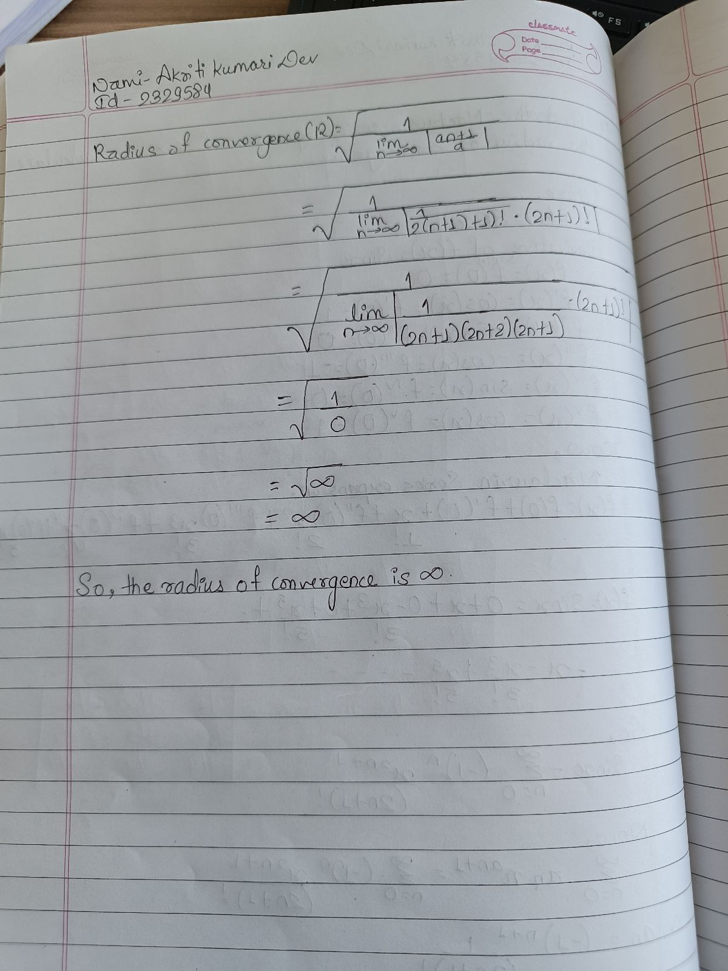

The End